**NATIONAL INSTITUTE OF TECHNOLOGY**

**KURUKSHETRA**



**PRACTICAL FILE**

**SUBJECT :-** **Programming Using Python**

**BRANCH :- CS-A-01**

**ROLL NO :- 12112003**

**Submitted to:-**

**Shweta Pandey mam**

**Submitted by:-**

**Priyanshu maurya**

**Experiment-4**

1. (Conversion from miles to kilometer) Write a program that displays the following table(note that 1 mile is 1.609 kilometers):

print("Conversion from Miles to Kilometer")

mile = 1.609

print("Miles\tKilometer")

for i in range(1, 11):

    print(i, "\t", i*mile)

OUTPUT

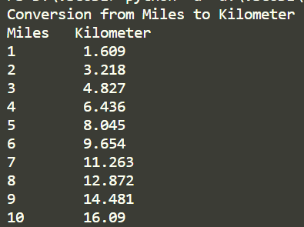

1. Suppose that the tuition for a university is $10000 this year and and increases 5% every year. Write a program that computes the tuition in ten years and the total cost of four years' worth of tuition starting ten years from now.

tut = 10000

for i in range(10):

    tut = tut+tut/20

print("Tution Fee from 10 years now = ", tut)

total_fee = 0

for i in range(4):

    total_fee += tut

    tut = tut+tut/20

print("Total Tution Fee of 4 years from 10 years now = ", total_fee)

OUTPUT



1. Write a program that displays ten numbers per line, all the numbers from 100 to 1,000 that are divisible by 5 and 6. The numbers are separated by exactly one space.

count=0

for  i in range(100,1001):

    if i%5==0 and i%6==0:

        print(i,*end*=" ")

        count+=1

        if count%10==0:

            print()

OUTPUT

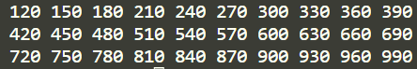

1. Write a program that displays the characters in the ASCII character table from! to ~. Display ten characters per line. The characters are separated by exactly one space.

char='!'

count=0

while 1:

    print(char,*end*=" ")

    count+=1

    if count%10==0:

        print()

    if char=='~':

        break

    char=chr(ord(char)+1)

OUTPUT

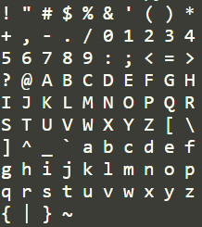

1. Use nested loop that display the following patterns in four separated programs:

for i in range(1, 7):

    for j in range(1, 7):

        if j <= i:

            print(j, *end*=" ")

    print()

OUTPUT

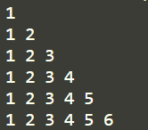

for i in range(6, 0, -1):

    for j in range(1, 7):

        if j <= i:

            print(j, *end*=" ")

    print()

OUTPUT

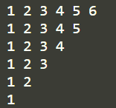

for i in range(1, 7):

    for j in range(6, 0, -1):

        if j <= i:

            print(j, *end*=" ")

        else:

            print(*end*="  ")

    print()

OUTPUT

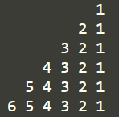

1. Write a nested **for** loop that displays the following output:

n = 6

for i in range(1, n+1):

    a = 1

    for j in range(n-i+2*i):

        if j <= n-i:

            print(*end*="\t")

        else:

            print(a, *end*="\t")

            if j >= n:

                a //= 2

            else:

                a *= 2

    print()

OUTPUT

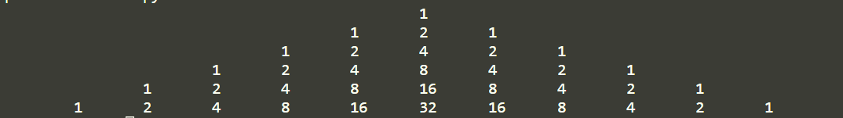

1. Write a program that lets the user enter the loan amount and loan period in number of years and displays the monthly and total payments for each interest rate starting from 5% to 8%, with and increment of 1/8.

loan_amt = *int*(input("Enter Loan Amount : "))

loan_per = *int*(input("Enter Loan Period(No. of Years) : "))

r = 5

amt = 0

while r <= 8:

    monthly_interest = r/1200

    monthly_payment = loan_amt*monthly_interest / \

        (1-(1+monthly_interest)**(-loan_per*12))

    amt += monthly_payment

    print("Monthly payment is ", monthly_payment)

    print("Total Payment is", amt*12*loan_per)

    r += 1/8

1. The monthly payment for the given loan pays the principal and the interest. The monthly interest is computed by multiplying the monthly interest rate and the balance (the remaining principal). The principal paid for the month is therefore the monthly payment minus the monthly interest. Write a program that lets the user enter the loan amount, number of years, and interest rate, and then displays the amortization schedule for the loan.

loan_amt = *int*(input("Enter loan amount: "))

year = *int*(input("Enter no of year: "))

rate = *int*(input("Enter interest rate : "))

monthly_interest = rate/1200

monthly_payment = loan_amt*monthly_interest/(1-(1+monthly_interest)**(-year*12))

for i in range(1, year*12+1):

    interest = monthly_interest*loan_amt

    principal = monthly_payment-interest

    loan_amt -= principal

    print(i, "\t\t", interest, "\t\t", principal, "\t\t", loan_amt)

1. A positive integer is called a perfect number if it is equal to the sum of all of its positive divisors, excluding itself. For example, 6 is the first perfect number, because 6 = 3 + 2 + 1 . The next is 28 = 14 + 7 + 4 + 2 + 1. There are four perfect numbers less than 10, 000. Write a program to find these four numbers.

import math

*def* perfect(*n*):

    sum = 0

    for i in range(2, *int*(math.sqrt(n)+1)):

        if n % i == 0:

            if i*i == n:

                sum += 2*i

            else:

                sum += i+n/i

    if sum+1 == n:

        return True

*def* main():

    print("Perfect NUmbers are: ")

    for i in range(1, 10001):

        if perfect(i):

            print(i)

if __name__ == "__main__":

    main()

OUTPUT

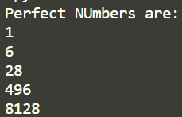

1. Write a program that displays all possible combinations for picking two numbers from integers 1 to 7. Also display the total number of combinations

for i in range(1,8):

    for j in range(i+1,8):

        print(i,j)

OUTPUT

